雲保科技股份有限公司

HRV MODULE
KY207
Specification Sheet
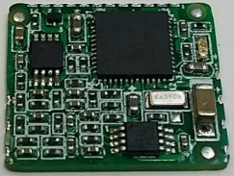
Features:
- UART link
- Easy PC Interface
- Time and Frequency Domain Analysis
- Compact module size for easy integration

ALL INFORMATION CONTAINED HEREIN IS THE SOLE PROPERTY OF CLOUD CARE INC. AND CANNOT BE DISSEMINATED WITHOUT THE EXPRESS WRITTEN CONSENT OF CLOUD CARE INC..
Change list
文件版本 | 變更說明 | 編修 | 日期
v0.1 |  |  | 2012/07/03
v0.2 |  | 李涵 | 2019/02/27

- Introduction
The KY207 is an evolutionary digital signal processing chip for heart rate variability (HRV) analysis. It incorporates the state-of-the-art technologies of heart rate variability analysis into one single chip. The technologies include R point detection, interpolation in time domain, and fast Fourier transform in frequency domain. The operation is fully automatic, and no command is needed. The input data can be in the form of analog waveform or digital series through UART input. The analysis result is formatted in ASCII codes (such as “HR=85”) and output through standard UART output. The module is suitable for various hand held application.
The KY207 is designed to allow quick and easy integration into EKG/HRV-related applications such as:
- Portable Health Care devices, especially on EKG/HRV applications
- Health Management
- Hand-held device for Home Care

  - Features
    - Hardware and Software
- Built-in high gain amplifier and bandpass filter
- Compact module size for easy integration
- SMT pads allow for fully automatic assembly processes equipment and reflow soldering
    - Performance
- Highest performance EKG/ HRV Engine.
- Extremely low weak signal tracking sensitivity
    - Interface
- UART port for communications interface
- Baud Rate: 4,800 bps
- Technical specifications
  - Module architecture
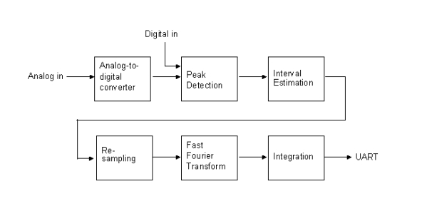
  - Hardware Features
- Based on the high performance features of the TI low power single chipset
- Built-in high gain amplifier and filter
- Frequency Range: 1.5- 32 Hz
- Sample Rate: 250 Hz
- Resolution: 10 bits
  - Software Features
The firmware used on KY207 module is low power single chipset, and the default configuration is as following description:

Command | STA
Function | Wake up from power down mode (turn on)
Parameters | Null
Delay Time (ms) | 10
Return | Null
Remarks | Enter active mode

Command | STP
Function | Reset and enter power down mode (turn off)
Parameters | Null
Delay Time (ms) | 10
Return | Null
Remarks | Power down mode 1uA

Command | STW
Function | Wake up from power down mode (turn on) and output waveform
Parameters | Null
Delay Time (ms) | 10
Return | Null
Remarks | Enter active mode and output waveform

Command | INIT
Function | Initialize
Parameters | Null
Delay Time (ms) | 10
Return | INIT
Remarks | Initialize operation

Command | W+ (W-)
Function | Toggle waveform output
Parameters | Null
Delay Time (ms) | 10
Return | Null
Remarks | Data output: “RAW=32” follow by 32 bytes wave from data Default: off
Command | S+ (S- )
Function | Toggle simulation
Parameters | Null
Delay Time (ms) | 10
Return | Null
Remarks | Generate simulation signal,  Default: off

Command | G+ (G- )
Function | Change Gain
Parameters | Null
Delay Time (ms) | 10
Return | Null
Remarks | G+ : increase gain by 2 folds (max 4 folds)  G - : decrease gain by 2 folds (min 1 fold)

Command | RAW=32
Function | Input digital data
Parameters | 32 bytes wave form data
Delay Time (ms) | 1
Return | Null
Remarks

UART Output result of KY207
Command | IHR=nnn.n
Function | Instantaneous heart rate
Remarks | n=0~9

Command | MHR=nnn.n mmm.m xx
Function | Mean heart rate
Remarks | n, m, x=0..9  nnn.n=mean heart rate (‘ni1’=no heart rate)  mmm.m=SD  xx=number

Command | CT=nnnn.n xx yy
Function | Physical activity
Remarks | n, x, y=0~9  nnnn.n=physical activity  xx=spin  yy=angle

Command | TI=nnnnn
Function | Time mark in second
Remarks | n=0~9

Command | RT=hhhhhhhh
Function | Second since 2000/1/1 0:0:0
Remarks | h=0~f in hex

Command | ST=1
Function | Start

Command | ST=0
Function | stop

Command | SR=nnn
Function | Sampling rate of the physiological signals
Remarks | n=0~9
Command | VER=an.nn
Function | Version
Remarks | n=0~9 a=ascii

Command | MSG=nnnnnnnn
Function | Message
Remarks | n=0~9

Command | TE=nnn mmm
Function | nnn=temperature  mmm=number of average
Remarks | n,m=0~9

Command | BAT=nnn mmm
Function | nnn=battery voltage (0=0V, 256=3.6V)  mmm=number of average
Remarks | n,m=0~9

Command | x=abcdef  abcd=serial number  ef=ab+cd  a,b,c,d,e,f in hex
Function | Output multiple channel data
Parameters | Index | Value | Description
Parameters | 0 | package_len-1 | Package length
Parameters | 1 | total_chn-1 | Total channel
Parameters | 2 | 0xMN | M=ratio of time point to data of chn0  N=ratio time point to data of chn1
Parameters | 3 or 1+total_chn2 | 0xOP | O=ratio time point to data of chn2  P=ratio time point to data of chn3  total_chn2=  (total_chn/2)+(total_chn%2)
Parameters | 2+total_chn2 to  2+total_chn2+data_size-1 | Data  AA aa BB bb CC cc … | data_size=  (package_len/M+  package_len/N+  package_len/O+  package_len/P)*2  AA, BB, CC high byte  aa, bb, cc low byte
Parameters | 2+total_chn2+data_size | check_sumh | check.sum  =check_sumh*256+check_sum1  =sum of index 0 to 2+total_chn2+data_size-1
Parameters | 2+total_chn2+data_size+1 | check_sum1

Example 1: ‘x=000101’ 04 03 11 11 AA aa BB bb CC cc ... TT tt XX xx

Serial number=0001 (hex)
Package length=5
Total channel=4
Ratio of time point to data=1, 1, 1, 1 for the 4 channels
Data=
 | ch0 | ch1 | ch2 | ch3
time point 0 | AAaa | BBbb | CCcc | DDdd
time point 1 | EEee | FFff | GGgg | HHhh
time point 2 | IIii | JJjj | KKkk | LLll
time point 3 | MMmm | NNnn | OOoo | PPpp
time point 4 | QQqq | RRrr | SSss | TTtt
Check sum=XXxx

Example 2: ‘x=000101’ 05 03 11 22 AA aa BB bb CC cc ... RR rr XX xx

Serial number=0001 (hex)
Package length=6
Total channel=4
Ratio of time point to data=1, 1, 2, 2 for the 4 channels
Data=
 | ch0 | ch1 | ch2 | ch3
time point 0 | AAaa | BBbb | CCcc | DDdd
time point 1 | EEee | FFff
time point 2 | GGgg | HHhh | IIii | JJjj
time point 3 | KKkk | LLll
time point 4 | MMmm | NNnn | OOoo | PPpp
time point 5 | QQqq | RRrr
Check sum=XXxx

- Performance Characteristics
  - Pin Positions
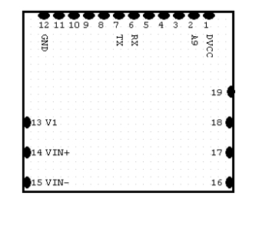
  - Pin Assignment
Pin # | Name | Type | Description
1 | DVCC | PWR | +3.3V~+2.7V
2 | NA
3 | NA
4 | NA
5 | NA
6 | RX | I | UART RX data receive
7 | TX | O | UART TX data transmit
8 | NA
9 | NA
10 | V2 | O | 1.8V
11 | AMP | O | 2.0V
12 | GND | I/O | GND
13 | V1 | O | ECG ref point(0.9V)
14 | VIN+ | I | ECG V+
15 | VIN- | I | ECG V-
16 | DIO | I/O
17 | DIO | I/O
18 | DIO | I/O
19 | DIO | I/O

- Software interface
The host serial I/O port of the module’s serial data interface supports full duplex communication between the module and the user. The default serials are shown in Table 4-1.
Table 4-1 KY207 module default baud rate
Port | Baud rate
Port A | 4,800 bps

- Mechanical drawing and footprint
  - Outline Drawing
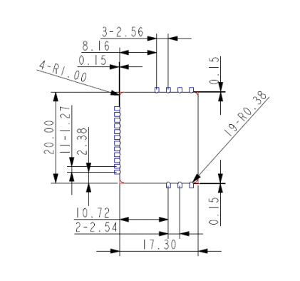
  - Recommended footprint ( Top view )
